**Task1:**

Step1: Download the **Sample-Superstore** Excel File and Connect to the Data.

Step2: In the Data Source tab, drag the Orders table from the left pane to the data canvas.

Step3: Double click on the Orders table box to display the Orders table.

Step4: Next, drag the Returns table onto the canvas and drop it near the Orders table**.**Step5: Tableau will prompt you with a **Join** configuration window. Ensure the join is set on the **Order ID** field. Select **Left Join**. Confirm the join and review the preview of the joined data to ensure the **Order ID** fields match.

Step6: Go to Sheet 1 to start building your visualization.

Drag the Sales field from the Orders table onto the Rows shelf. Drag Returned and Sub-category from the Returns and Orders table onto the Columns shelf. Drag the Sub-category to the Color shelf in the Marks card**.A screenshot of a computer
**

The chart breaks down sales by sub-category (Appliances, Chairs, etc.) and whether those items were returned (Yes, No, or Null for missing data in the Returns field). Each bar's color represents a different sub-category of products. The chart includes both returned and not returned items, enabling easy comparison of how returns affect sales per sub-category.

Step 7: Go back again to the Data Source Tab. Drag **the People** table from the left pane to the data canvas.  Ensure the join is set on the **Customer Name** from **Orders** and **Person** from **People**. Select **Inner Join.**A screenshot of a computer

Step 8: Go to **Sheet 2** to start building your visualization. Drag the **Sales** field from the **Orders** table onto the **Rows** shelf. Drag **Sub-category** from the **Orders** table onto the **Columns** shelf. Drag the **Person** from the **People** table to the **Color** shelf in the **Marks** card.

The above visualization displays total sales data broken down by product sub-categories (e.g., Tables, Appliances, Chairs) and further segmented by individual salespersons. Each stacked bar represents the sum of sales for a sub-category, with different colors showing contributions from different persons. Notably, sub-categories like Storage and Chairs dominate in total sales, with certain individuals contributing more significantly to those categories. In contrast, smaller categories like Fasteners have relatively low sales figures. The visual breakdown reveals key insights into product performance and team contribution, suggesting potential areas for sales optimization and resource allocation.

**Question 1:**

Analyze the Impact of Joins. Switch between different types of joins (e.g., Inner Join, Left Join, Right Join, Full Outer Join) and analyze how the visualizations change.

**Task -2**

Step1: Download the "Superstore" Excel file. Open Tableau and connect to the Excel data source.

Step2: In a new worksheet, click on the drop-down arrow next to the View Data, and then select **Create Parameter** to open the parameter creation dialog box.

Step3: Enter the parameter name, choose the data type, and select ‘List’ for allowable values. Then, input the specific values you want to include in the parameter. Click ok.

Step4: You can now see the newly created parameter, listed under the Parameters section. Click on show Parameter as shown below.

Here, **Date Level Selector** is the parameter you created in the previous step. This calculated field will dynamically adjust the OrderDate format based on the selection in the parameter. Click Apply and then OK to save the new calculated field named **Date Selector**.

Step6: Drag the **Date Selector** calculated field to the **Columns** shelf and the **Sales** attribute to the **Rows** shelf. This setup will create a visualization that displays sales data.A screenshot of a computer

Step7: In the Marks section, change the mark type to ‘Line’. This will transform your visualization to a line chart, allowing you to better visualize trends in sales over the selected date intervals.

Step8: Change the Date Level Selector parameter to **Quarter**. This will allow you to view the sales data in months, displaying the sales figures within the selected quarters in your line chart.

Step9: Similarly, you can change the Date Level Selector parameter to **Month** to view the monthly sales data. This will adjust the visualization to display sales figures for each individual month, allowing for a more detailed analysis of sales trends over time.

Step 10: Furthermore, you can extend this analysis by adding additional options to the **Date Level Selector** parameter for **Week** and **Day**.

* Even though we can directly add date attributes like Year/Month/Quarter/Week/Day to the column shelf, in this case, you are creating a parameter based on the **Order Date** and writing a custom function. This approach also allows us to analyze the data at various time intervals dynamically.
* It helps in understanding trends and patterns over time at multiple levels of granularity, such as year, quarter, month, week, and day, all within a single view. This method gives users more control over the visualization and enables insights into the data.

***Question2:***

1.Continue in the above tutorial,

Create a new parameter as **Sales Growth Rate**.

Set the **Data Type** to **Float**.

For **Allowable Values**, select **Range**.

Set the **Minimum value to 0**,

the **Maximum** **value to 1**, and

the **Step Size** to **0.05**.

2. create a new calculated field named ‘**Adjusted Sales’**

Enter the following function in editor,

**SUM([Sales]) * (1 + [Sales Growth Rate])**

3.Utilize the ‘**Adjusted Sales’** calculated field to compare sales by modifying the ‘Sales Growth Rate parameter’. Select a suitable chart type, such as a line chart, to visualize the trends.

4. Switch between Year, Quarter, Month using the ‘**Date Level Selector**’ parameter to analyze the impact.

5. Analyze the visualizations and explain your understanding of the task.

***Task3:***

**Key Performance Indicator (KPI)** is a measurable value that demonstrates how effectively an organization is achieving its business objectives. KPIs help assess performance, inform decision-making, and align efforts across teams. By tracking KPIs, organizations can identify areas for improvement and ensure progress toward their goals.

Step 1: Use the Superstore dataset and create a new worksheet titled "Sales KPI." Place the **Categories** in the Rows shelf, **Sales** in the Text shelf, and regions in the Columns shelf.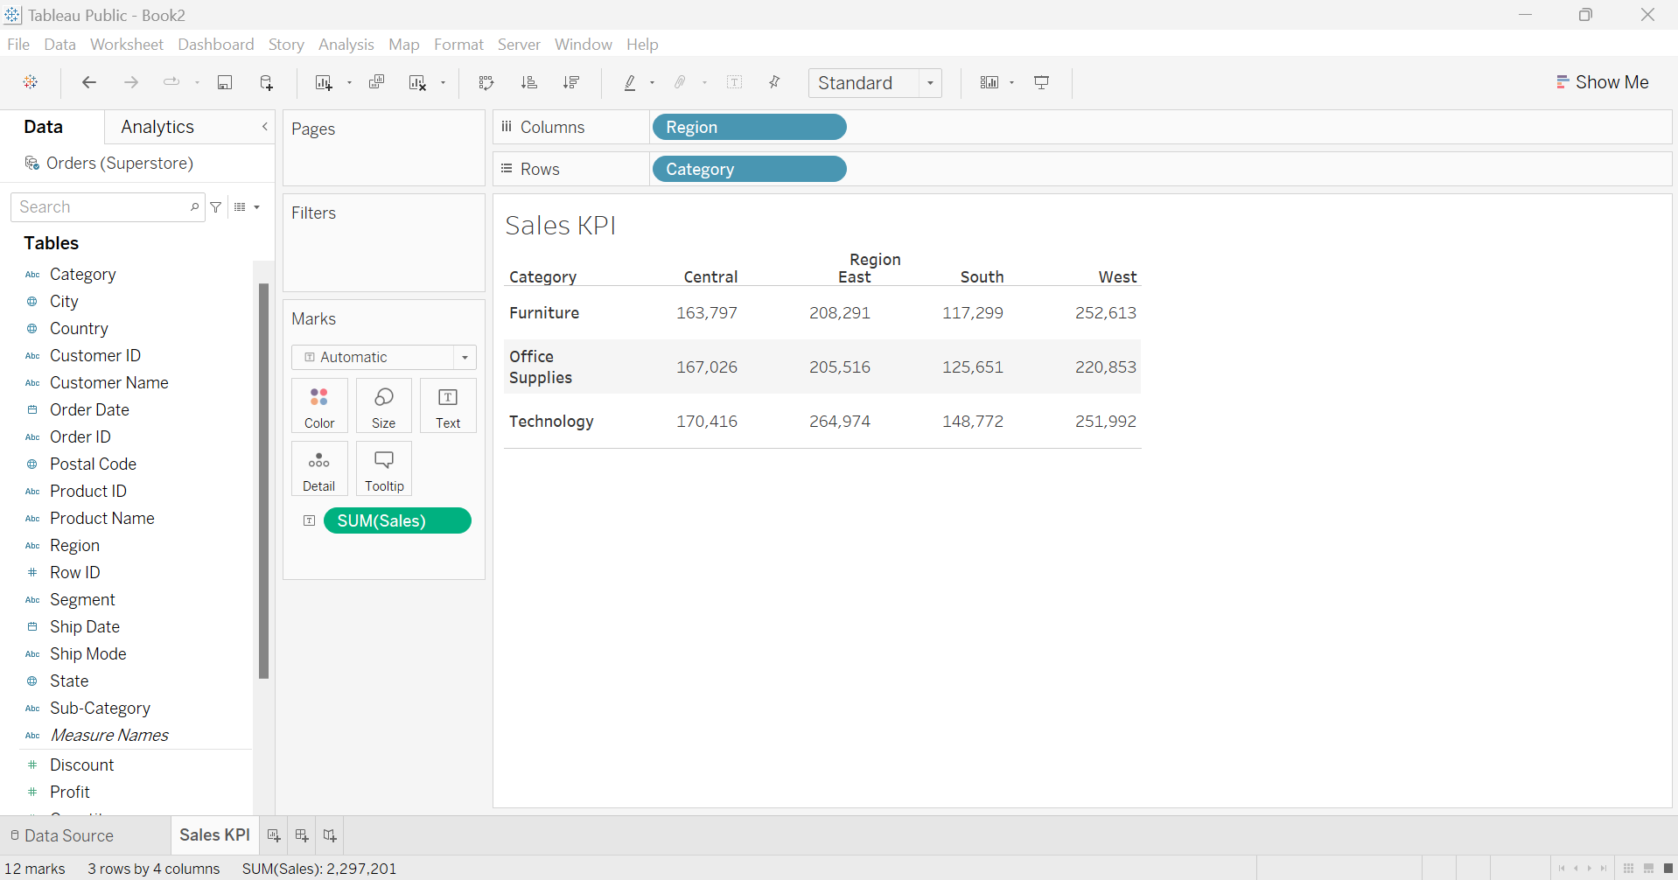

Step2: Create a calculated field called "BenchMark KPI" and give the function as shown.Click ok.

Step3: Drag the "BenchMark KPI" field to the Color shelf.

Step4: You can customize the colors by edit. Assign green for values above the benchmark and red for values below the benchmark, based on the conditions you set in the calculated field. This visual distinction helps quickly identify performance relative to the target.A screenshot of a computer

Step5: Change the mark type to **Shape**

Step6: By default, Tableau uses a hollow circle shape. Since we don’t need the sales values displayed, you can move the sales information to the Detail shelf.

Step7: To change the shape, click on the **Shape** shelf, then select **More Shapes**. Choose **KPI** from the Shape Palette and select the desired shape for visually more attractive. Once done, click **OK** to apply the changes.

Step8: You can see that the **Furniture** category is not performing great in the **South** region, indicating that the business should focus on improving sales in this area, as it falls below the benchmark.

***Question3****:*

1. Create a new worksheet titled **Sales KPI-II**. Set up the visualization by dragging the following fields to the appropriate shelves:

**Sub-category** to the Rows shelf

**Order Date** to the Columns shelf

**Sales** to the Text shelf

2. Evaluate the performance of subcategories based on their **Sales** across different **years**.

Create a calculated field named **Target KPI** with the following criteria :

* If the total sales for any subcategory in any year exceed 25,000, categorize it as **"Above Target."**
* If the total sales for any subcategory in any year are 25,000 or lower, categorize it as **"Below Target."**

Write the function for the **Target KPI** calculated field in the calculated field editor for the given criteria.

3. Change the mark type to **Shape**, as specified in Step 5, and move the **Sales** field from the Text shelf to the Detail shelf, as indicated in Step 6.

4. Drag the **Target KPI** field to the Color shelf. By default, "Above Target" will be represented in a circle shape, while "Below Target" will appear as a square shape.

Change the shape to a tick mark from the KPI palette and assign the colors as specified below.



5. Analyze the visualization and explain your understanding.